Week 6
- ReactJS HOL
Explain React components
React components are the core building blocks of a React application. They represent parts of the UI and can be reused. Each component returns JSX, which is rendered as HTML in the browser.

Identify the differences between components and JavaScript functions
Aspect | React Components | JavaScript Functions
Purpose | Used to build and manage UI | Perform a specific task or logic
Return value | Returns JSX (UI) | Returns any value (number, string)
React-specific features | Can use state, props, hooks, lifecycle | Cannot use React features
Reusability in UI | Designed for reuse in UI structure | Not specifically for UI

Identify the types of components
- Class components
- Function components

Explain class component
A class component is a component defined using a JavaScript class. It extends React.Component and must include a render() method that returns JSX. It supports state and lifecycle methods.

Explain function component
A function component is defined using a JavaScript function. It returns JSX directly and can use React Hooks to manage state and side effects.

Define component constructor
The constructor is a method in class components used to initialize state and bind event handlers. It’s called before the component is mounted.

Define render() function
The render() function is a required method in class components. It returns JSX which tells React what to display in the UI.
Steps:-
App creation:
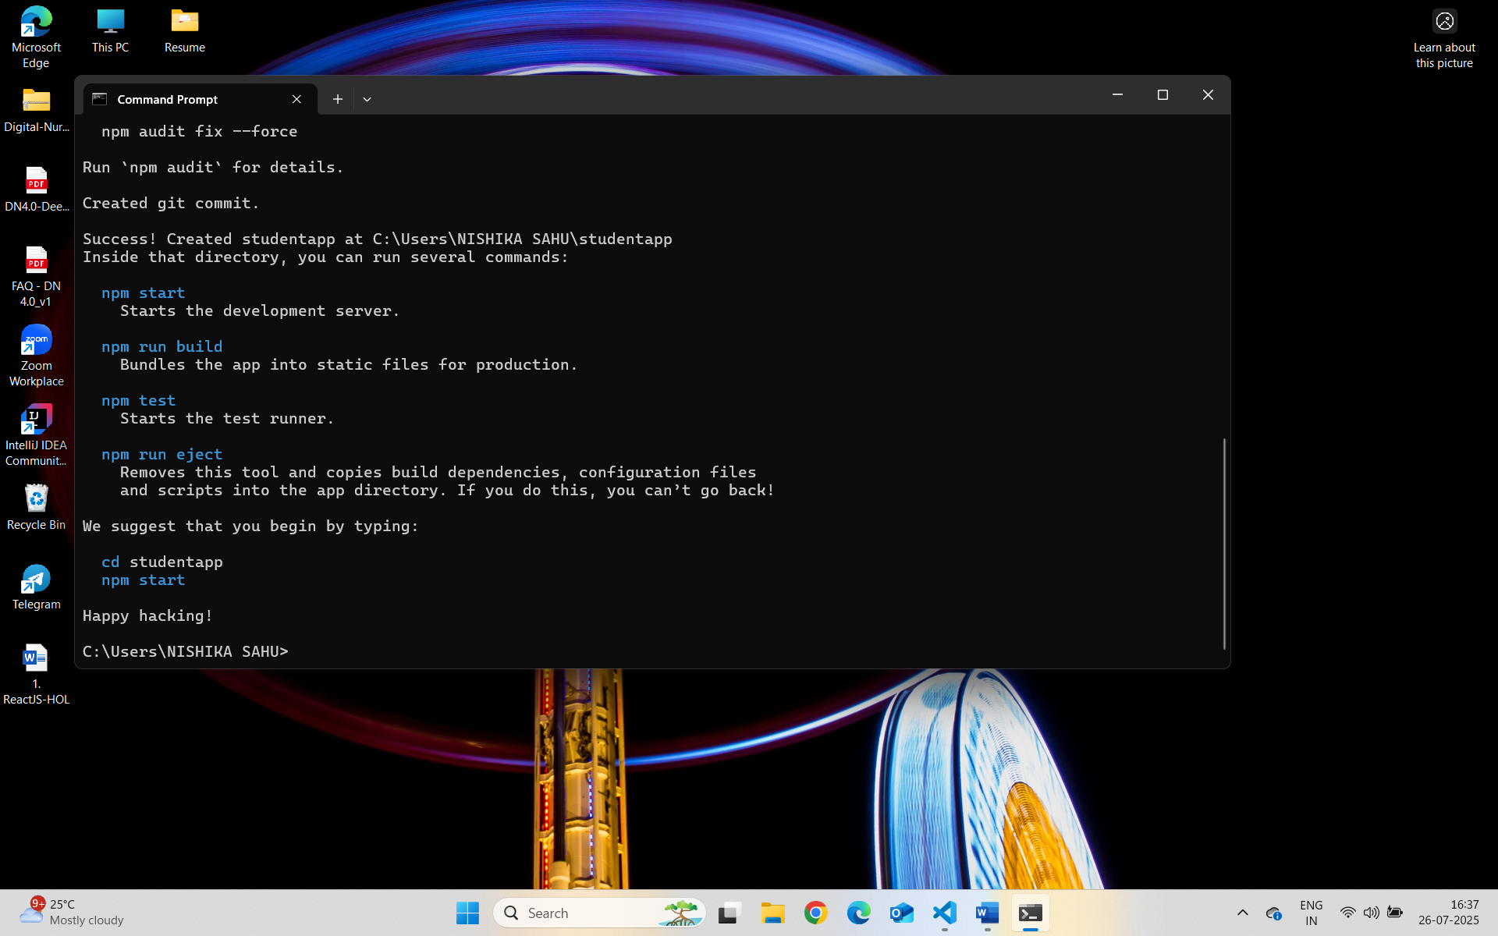
App.js:
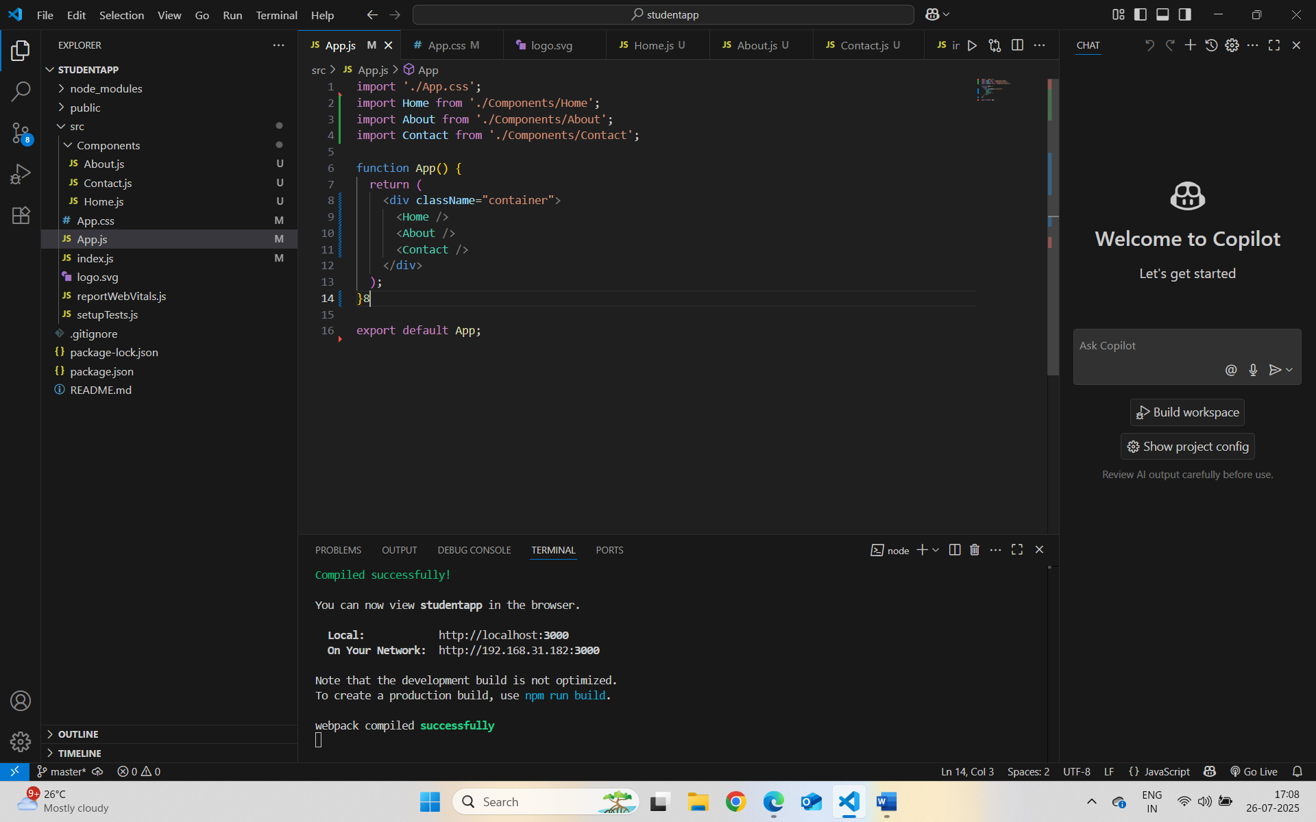

App.css:-
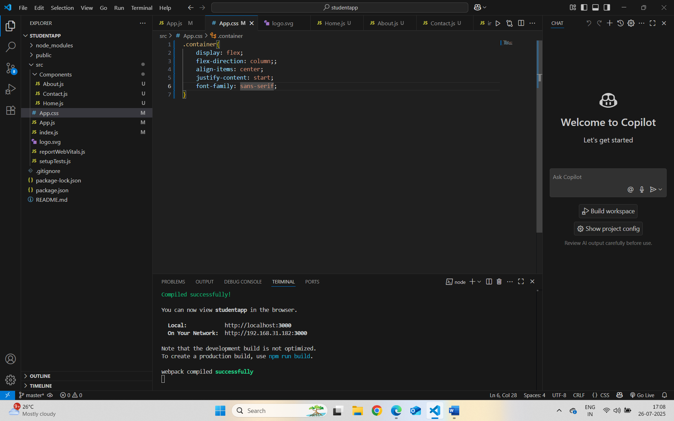
Home.js:-
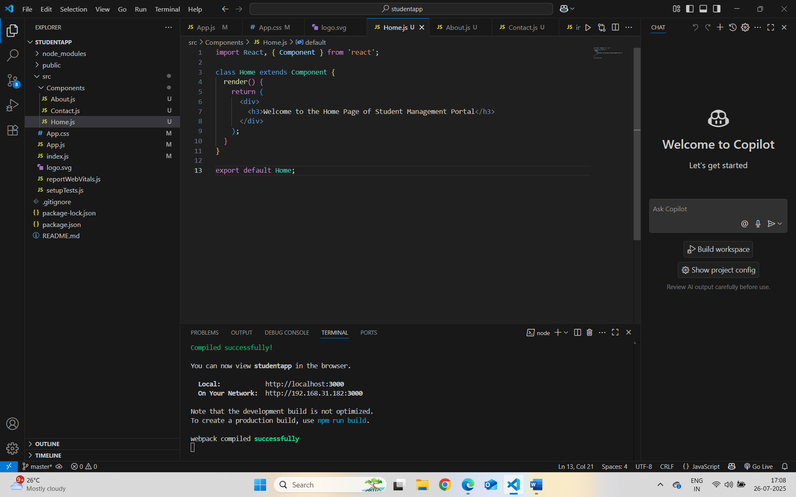
About.js:-
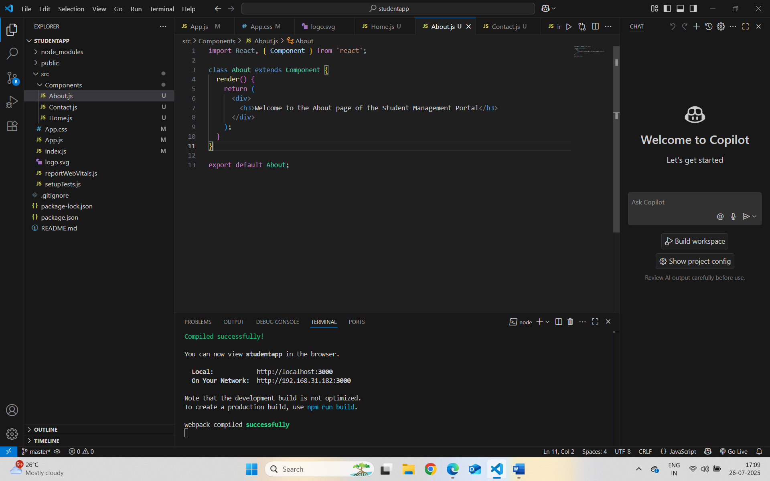
Contact.js:-
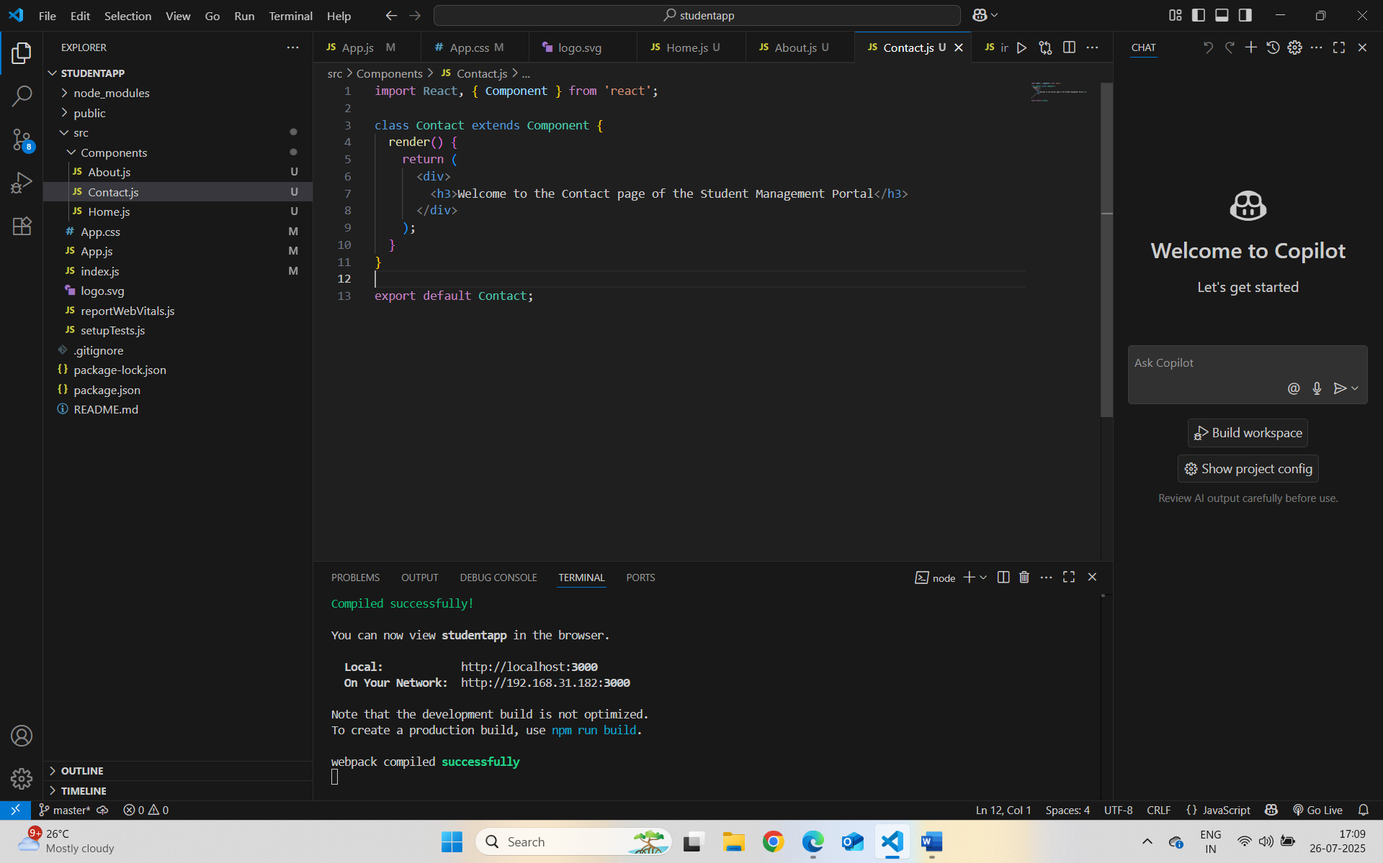
Localhost:3000 :-
